**MLCC Project – House Value Estimation**

**Explanation about work**

When it comes to predicting real estate prices, there are many different machine learning algorithms to choose from, such as decision trees, random forests, and neural networks. However, linear regression is a simple and effective algorithm that can provide accurate results for many real-world problems, including predicting house prices.

**Linear regression works by finding the line that best fits the data, by minimizing the difference between the predicted values and the actual values.** In the case of real estate price prediction, linear regression can be used to find the relationship between the different features of a house (such as square footage, number of bedrooms, and location) and the sale price.

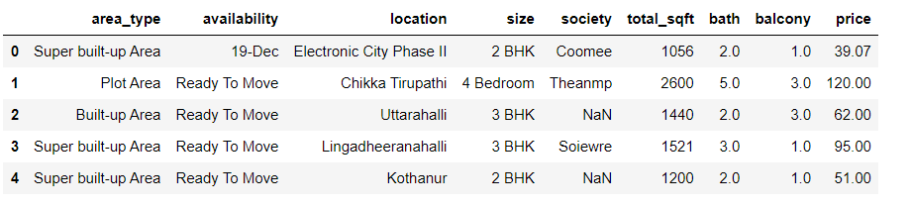

One of the reasons why linear regression is a good choice for this type of problem is that it can handle both numerical and categorical features. For example, the number of bedrooms is a numerical feature, while the location of the house is a categorical feature. Linear regression can handle both types of features and provide accurate predictions.

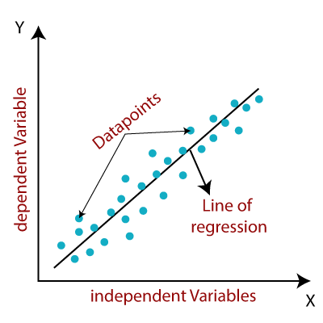

Another advantage of linear regression is that it is a relatively simple algorithm that is easy to interpret. This means that we can easily understand how the different features of a house contribute to its overall sale price. This is important for real estate agents and buyers who need to make informed decisions based on the predicted prices.

Overall, linear regression is a good choice for real estate price prediction because it is simple, effective, and can handle both numerical and categorical features. By using this algorithm, we can build a model that can accurately predict house prices based on the desired parameters.

